Pipelined ADC

Target values:
$$Fsample=100 MHz$$
Each block/phase is 3 bits.
Output consists of the 3 bits calculated and the resulting quantization error with a gain of 4.
ADC is to use flash topology.
ADC and DAC propagation delay must be less than 10ns (1/Fsample)
Input is 0-5V

References:
AD pipelined adcs: https://www.analog.com/media/en/training-seminars/tutorials/MT-024.pdf

Sample n hold

Analog switch

Nexperia 74LVC4066 (Quad switch)
Turn on and off with prop delay is 9.5ns. Does not have spice model, but see if I can get it with Kardium email. This would give 0.5ns of charging worst case. Turn off is 5ns so input clock could go directly to this switch. With 50R input and switch conduction of 10R, 0.5ns with a voltage increase of 5V (FS) results in a sample cap of 200fF… Using 50pF hold cap results in a min charge time of 87ns to reach 99%. This would result in ~10MHz sample rate.
Look into this for future higher speed implementations
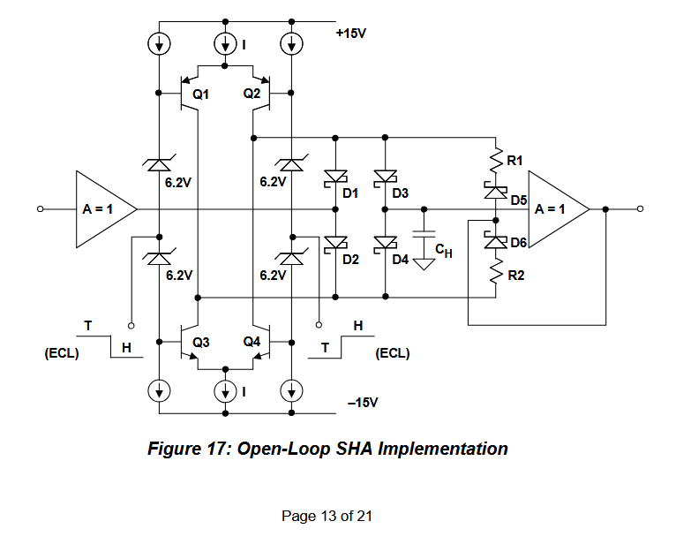
https://www.analog.com/media/cn/training-seminars/tutorials/MT-090.pdf

ADC

Comparator

DAC

Output buffer?

Error/Summing block

Opamp

Gain (4x)

Opamp

Digital logic

